# Caremark.com – Help Center

Help Center Feedback Collection

Help Center – Unauthenticated Sign In Page

Help Center – Authenticated Home / Dashboard

Example Q & A – Order Status and History

Contact Caremark / Contact Us

Related Documents

**Description:** Provides information on how to assist a member with navigating the Help Center on desktop and the mobile site.

**Note:** At-home COVID-19 test reimbursement claim formsthat can be printed and mailed are available in the Help Centerfrom theCOVID-19 Resource Center. Refer to [Caremark.com - Forms For Print and Adobe Reader (038391)](C:\\Users\\ABuccilli\\AppData\\Local\\Microsoft\\Windows\\INetCache\\Content.Outlook\\2PO53Y4H\\CMS-PCP1-038391).

Screen capture might not match actual scenario for this process. Some clients may not enlist in specific web features. This work instruction/job aid is intended as a guide only.

|  |
| --- |
| Help Center Feedback Collection |

* Feedback collection is available for all clients that have the Help Center.
* Feedback collection features prompts for “Was this helpful?” with optional open text feedback submission.
* Feedback disposition and open text answer is sent to Enterprise Customer Contact (ECCR) and Tableau Dashboard.
* The Help Center is available on desktop, mobile web, and mobile app.

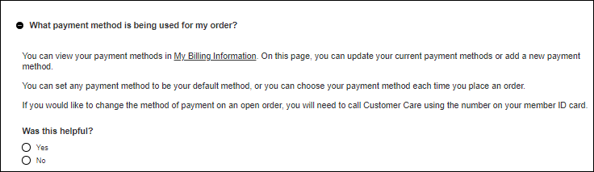

* If **No** is selected, text box appears to submit feedback. Click **Submit feedback**.

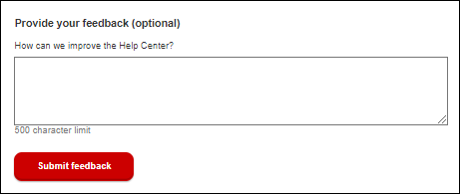

The user interface (UI) supports up to 9 categories, as well as prioritized marketing spots.

**Content:**

1. Visit the CVS Caremark Welcome Center
2. Visit the COVID-19 Resource Center
3. Order Status & History
4. Cost & Coverage
5. Ordering Prescriptions
6. Payments & Billing
7. Drug & Information Safety
8. Web & Account Support
9. Glossary



The following groups **do not** see the new Help Center in the authenticated state, but are directed to the existing **Contact Us** page experience until we enable the Help Center for all clients. The Help Center is available for unauthenticated members.

* **FEP Members:** For contractual reasons, FEP members do not see the new Caremark.com Help Center as it refers to Mail Order benefits. The Help Center will remain OFF for FEP until we are able to support customized client/plan content.
* **Early Registration and Termed Members:** Caremark.com Help Center is only available for members with active benefits.

The Help Center supports deep linking to other pages on Caremark.com. Authenticated members are taken to the page. Unauthenticated members are prompted to sign in and are then taken to the appropriate page.

The Help Center is compliant with all Accessibility requirements.

Top of the Document

|  |
| --- |
| Help Center – Unauthenticated Sign In Page |

Instruct the member with these steps to access the Unauthenticated Help Center on Desktop:

|  |  |
| --- | --- |
| **Step** | **Action** |
| **1** | Access [www.caremark.com](http://www.caremark.com). |
| **2** | Click **Visit our help center** at the bottom of the Caremark.com homepage.    **Result:** The Help Center displays. |
| **3** | Members can click on the triangle to expand each question and find the answers under each topic.  The **Contact Us** link at the bottom of the **Help Center** links members to existing **Contact Us** experience. To send a secure message via the Secure Message Center, members must register or sign in to their Caremark.com account. Members may also call Customer Care at the number listed on their prescription ID card. |

Top of the Document

|  |
| --- |
| **Help Center – Authenticated Home / Dashboard** |

Instruct the member with these steps to access the Authenticated Help Center on Desktop:

|  |  |
| --- | --- |
| **Step** | **Action** |
| **1** | Sign into [www.caremark.com](http://www.caremark.com). |
| **2** | Access the **Help Center** from the link in the header from the Dashboard.    **Result:** The Help Center displays. |
| **3** | Members can click on the triangle to expand each question and find the answers under each topic. |

Top of the Document

|  |
| --- |
| **Example Q & A – Order Status and History** |

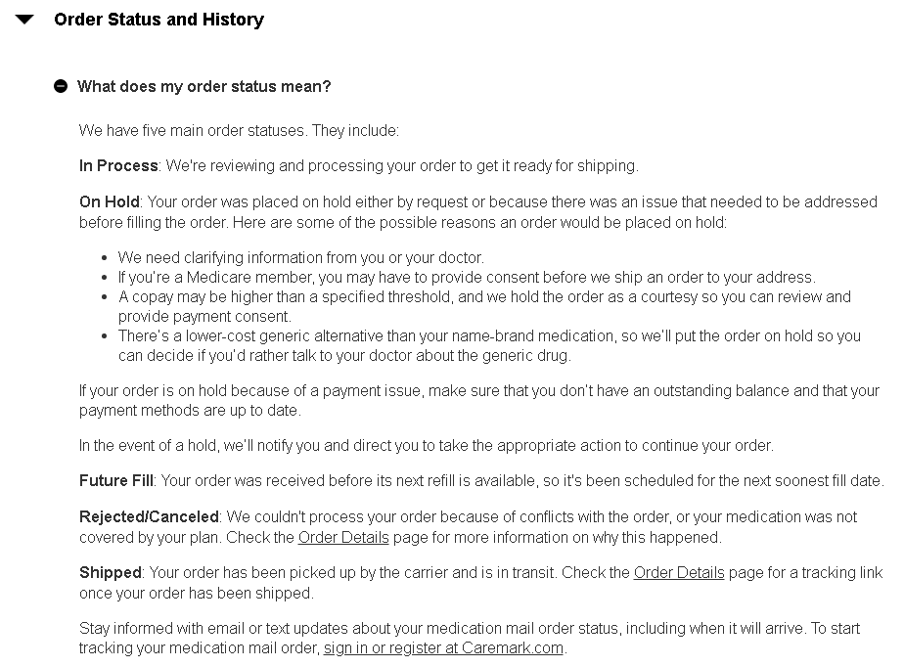

Top of the Document

|  |
| --- |
| **Contact Caremark / Contact Us** |

The **Contact Us** link located at the bottom of the **Help Center** links members to the **Contact Us** experience:

* Members can access Web Support FAQs, My Account FAQs, and Automatic Refills FAQs.
* Members can send a secure message via the **Secure Message Center** by selecting **Compose a message.**
* Members are provided with a telephone number to reach Customer Care and address to write to Caremark.

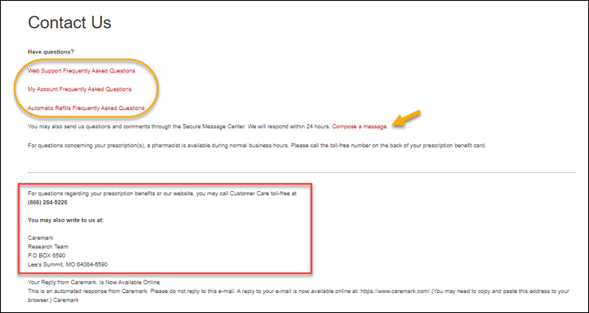

Top of the Document

|  |
| --- |
| Related Documents |

**Parent SOP:** [CALL 0045 Customer Care Web Support Email Response and Handling](https://policy.corp.cvscaremark.com/pnp/faces/DocRenderer?documentId=CALL-0045)

[CALL 0011 Authenticating Caller](https://policy.corp.cvscaremark.com/pnp/faces/DocRenderer?documentId=CALL-0011)

**Abbreviations/Definitions:** Customer Care Abbreviations, Definitions, and Terms

**Index:** Caremark.com - Work Instruction/Job Aid Index

Top of the Document

Not To Be Reproduced Or Disclosed to Others Without Prior Written Approval

**ELECTRONIC DATA = OFFICIAL VERSION – PAPER COPY – INFORMATIONAL ONLY**